**ST. XAVIER’S COLLEGE**

**(Affiliated to Tribhuvan University)**

Maitighar, Kathmandu



**DATABASE MANAGEMENT SYSTEM**

**LAB ASSIGNMENT#7**

**Submitted by:**

Shreesha Pokharel

013BSCCSIT038

**Submitted to:**

|  |  |
| --- | --- |
| **Er. Sanjay Kumar Yadav** |  |

Lecturer

Department of Computer Science

Date of submission: 25th September, 2015

1. Find the eno, ename, salary of the employee whose salary is >4000

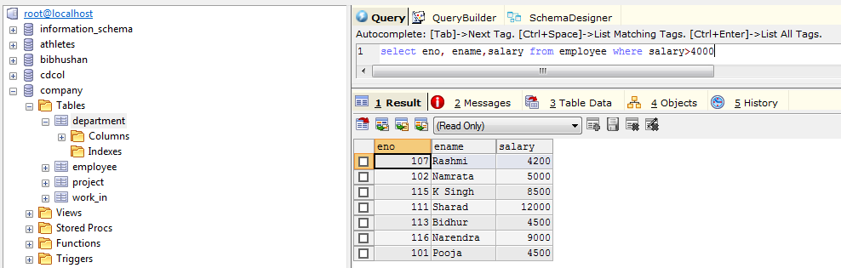

1. Find the eno, ename, salary of the employee whose salary is >5000 and job status is professor

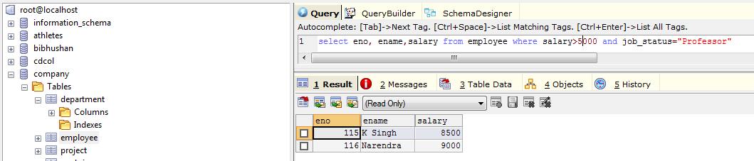

1. Removing duplicates

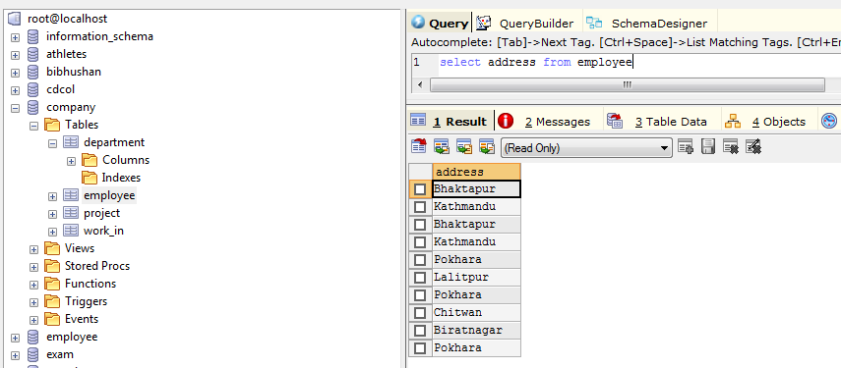

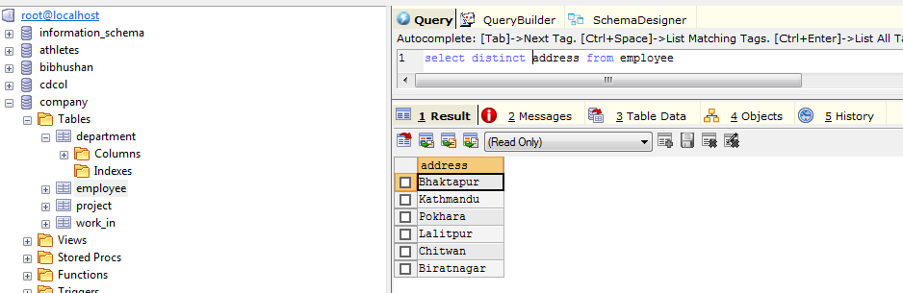

1. Find the eno, ename, salary whose dept no is 20 or job status research fellow.

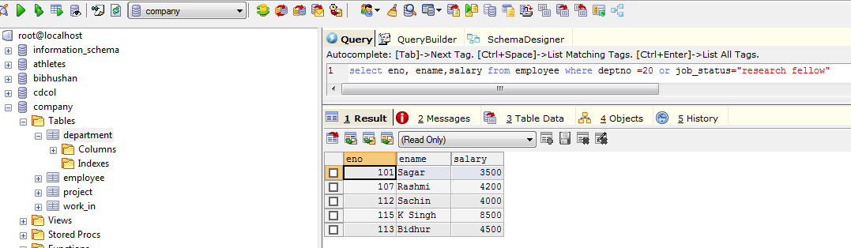

1. Find the eno, ename, age and salary from the employees where the age is between 24 and 28.

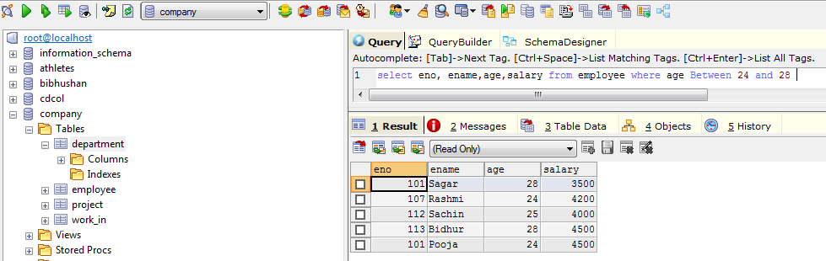

1. Find eno, ename whose starting letter is sa.

Keyword: like

‘ABC%’ all strings that start with ABC.

Eg: Abcd and abcdabcd both would satisfy the condition.

’%xyz’ all strings that end with xyz.

Eg: Wxyz and zzxyz both would satisfy the condition.

‘%an%’ all strings that contain the pattern an anywhere

Eg: Los angeles and san Francisco both would satisfy the condition.

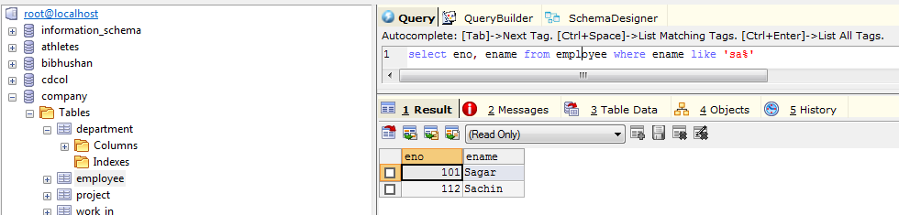

1. List all employee names with their project name

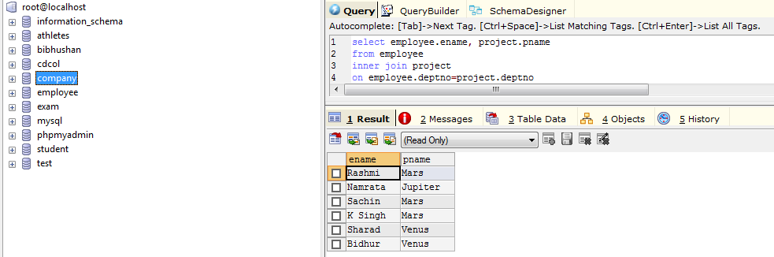

1. List name of all employees and their salary who are working in project mars or venus.

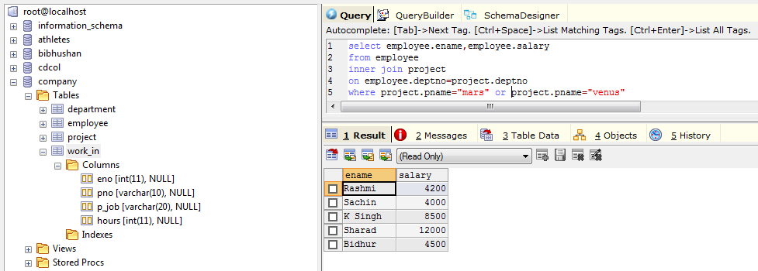

1. List name of all employees and their salary who are working in project earth and venus.

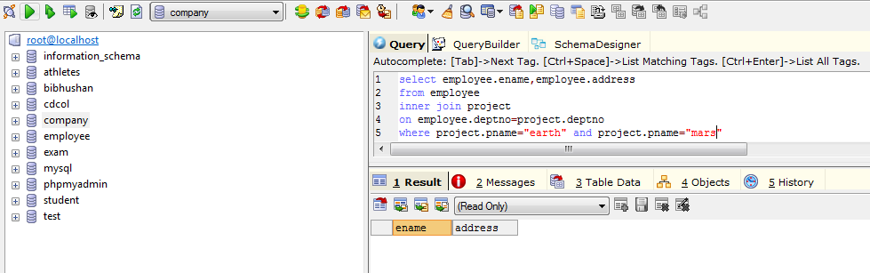

1. List name and address of all employees who work in department located in Pokhara.

